Team Project
(Due: Wednesday, May 14th, 2024 – End of day)
Worth [20%]
No late submissions accepted.
In groups of (3-4) already established, create a network topology based on the client interview and main site inventory.
The audit document should have the following sections:
- Actual situation
- Solutions/ Recommendations
  - Solution 1
  - Solution 2
- Conclusions
- Appendix
  - Terms and definitions
  - Network diagrams
  - Inventory List
The body of the document (excluding title page, table of contents and any appendices) should be 3 to 4 pages in length. The issue is quality not quantity. The length of the appendices may vary depending on the proposed solution.
At least two viable solutions will be proposed and let the client decide. The solutions do not have to be 100% different one from each other, one may include propositions from the other.
Hypothesis:
- Each employee has a computer, less production, where the computers are shared.
- Elements of the network available in the Packet Tracer will be used.
- The internet connection is considered a Cloud connection.
- Prices for upgrade/ replacement will be checked on the Canadian websites only.
Deliverables:
- The proposal document with appendices. (25%)
- A PowerPoint presentation with two scenarios as solutions. (10%)
- Presentations 15 min last two days of class (10%)
- The hardware implementation diagram and/or the Packet Tracer diagram of the chosen solution named: Team#_Net_s#.pka (50%)
- Self and peer evaluation document filled by each student (5%)
Resources:
https://www.citizensfla.com/documents/20702/2847745/20160927+02H+OIA+2016-AUD-IT-01+Network+Design+and+Architecture+Report+Executive+Summary+.pdf/e89c9822-434e-4e52-88f1-170a7aa9a332
https://searchitchannel.techtarget.com/feature/Channel-Checklist-10-steps-for-network-documentation

Client Interview
Q: Why do you need our services? What are the problems/ issues with the network?
A: Our company is planning an expansion, and we already bought a new location on the other side of the town around 10 km away from our main location.
Q: What are the requirements/challenges, for the new location?
A: There is a constant need to connect to our file server and to the product design software hosted on our servers.
Q: What services you currently have on the servers in the main location?
A: Oh, a lot. So, we have a webserver containing the website for orders, there is the accounting software that is integrated with the webserver and there is the production design software that resides on the server. Each order contains the detailed designs, so there are a lot of files, and, yeah, we are running out of space.
Q: How the server performs? Will they accept a load increase?
A: The services are stable, but sometimes there is lag and we do not know where is coming from.
Q: What do you think about the cloud technologies?
A: We already that the email and some storage space for backups in the cloud. On the long run, I think the cloud technologies will become popular, but they are still expensive. I was thinking that a seven-year conversion rate will be acceptable (price of hardware + maintenance = sever year cloud price). Also, we have a lot of custom development done for website and the accounting software integration. I do not know how this will be upgraded to the cloud.
Q: Do you have WIFI? Would you have the same on the new location?
A: Yes, for our employees and the clients.
Q. Other services that will use the internet connection?
A: We work from home in a hybrid schedule. Now I am using remote desktop. It would be nice to have VPN capabilities.
Q: Other services/devices attached to the network?
A: Yes, lots of printers and multifunctional printers.
Q: How many departments and employees in each department you have?
A: There is Accounting and Reception 6, Management 3, Engineering 12, Production 80, Sales 4, IT 2, Receiving/Shipping 2.
Q: What about the employees of the new location?
A: We are expecting to add half the size of our current staff.
Q: When do you expect to start production on the new location?
A: ASAP. Provide us with the plan of network expansion and requirements for the main location and will make it happen.

Main Site Inventory

- Internet connection – 1GB
- CISCO ASA – firewall appliance
- Switches – 3x 48 ports
- Routers 3x, one for Wi-Fi, one for internal network, one for VOIP.
- VOIP Phones – 36 devices
- Desktops – Windows 10 – 42x
- Server – Dell PowerEdge 400 series (16 core, 64 GB RAM, 1.2 TB RAID 10)
- NAS – 4TB RAID 10

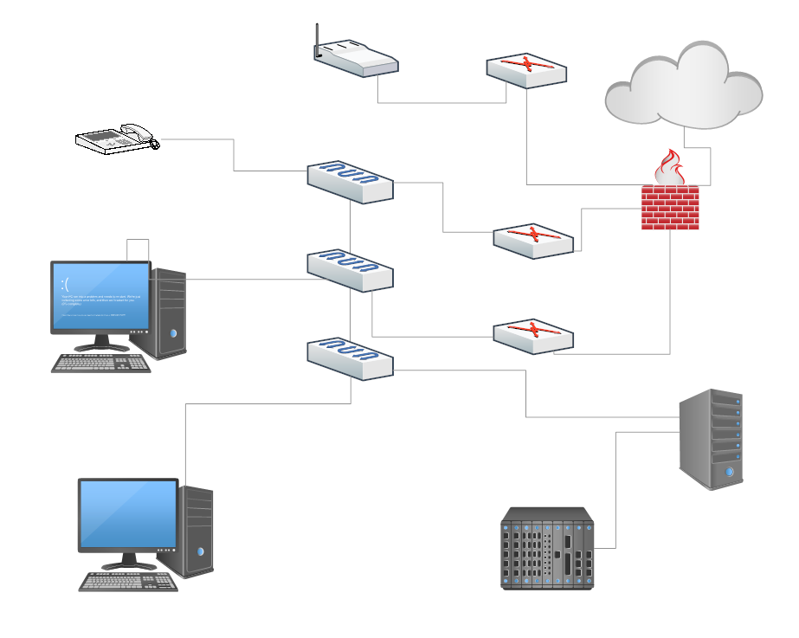

Self / Peer Evaluation
Team Number: ______________

Team member #1 name (Your Name): ___________________________________
 | Rarely | Sometimes | Mostly | Always
Did a fair share of the work involved
Was cooperative / completed their allocated task(s)
Contributed to ideas / planning / preparation
Was positive and helpful throughout

Team member #2 name: ___________________________________
 | Rarely | Sometimes | Mostly | Always
Did a fair share of the work involved
Was cooperative / completed their allocated task(s)
Contributed to ideas / planning / preparation
Was positive and helpful throughout

Team member #3 name: ___________________________________
 | Rarely | Sometimes | Mostly | Always
Did a fair share of the work involved
Was cooperative / completed their allocated task(s)
Contributed to ideas / planning / preparation
Was positive and helpful throughout

Team member #4 name: ___________________________________
 | Rarely | Sometimes | Mostly | Always
Did a fair share of the work involved
Was cooperative / completed their allocated task(s)
Contributed to ideas / planning / preparation
Was positive and helpful throughout

